Step 1: Take off the top and bottom of the track.
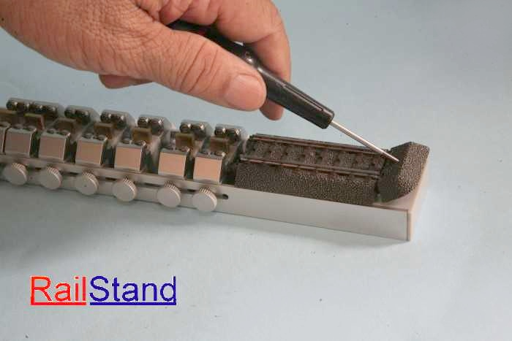

Step 2: Connect two roller test stands by the track.
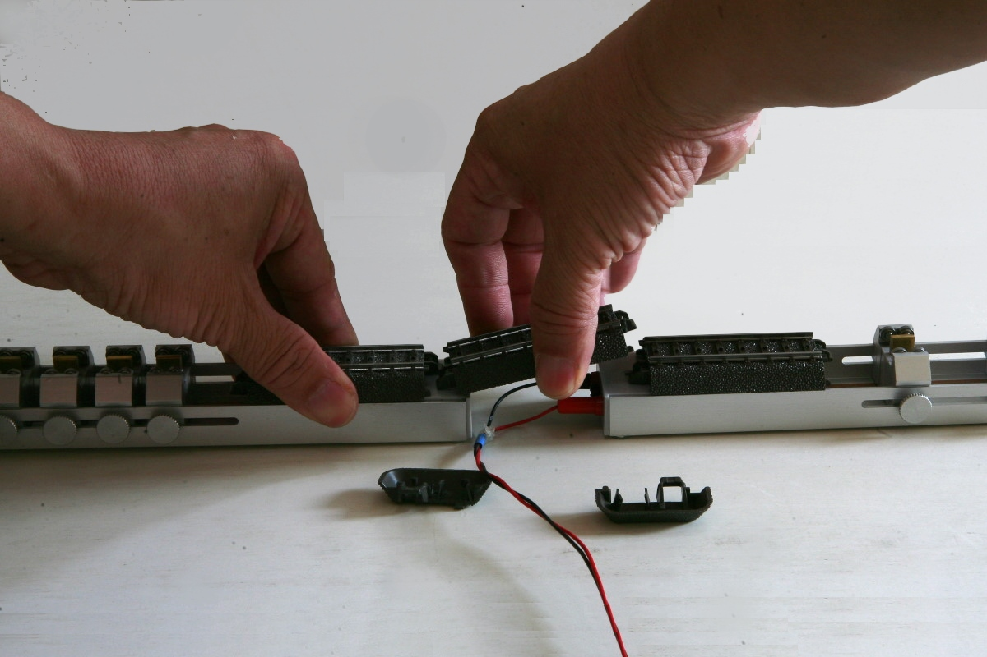

Step 3: finished.
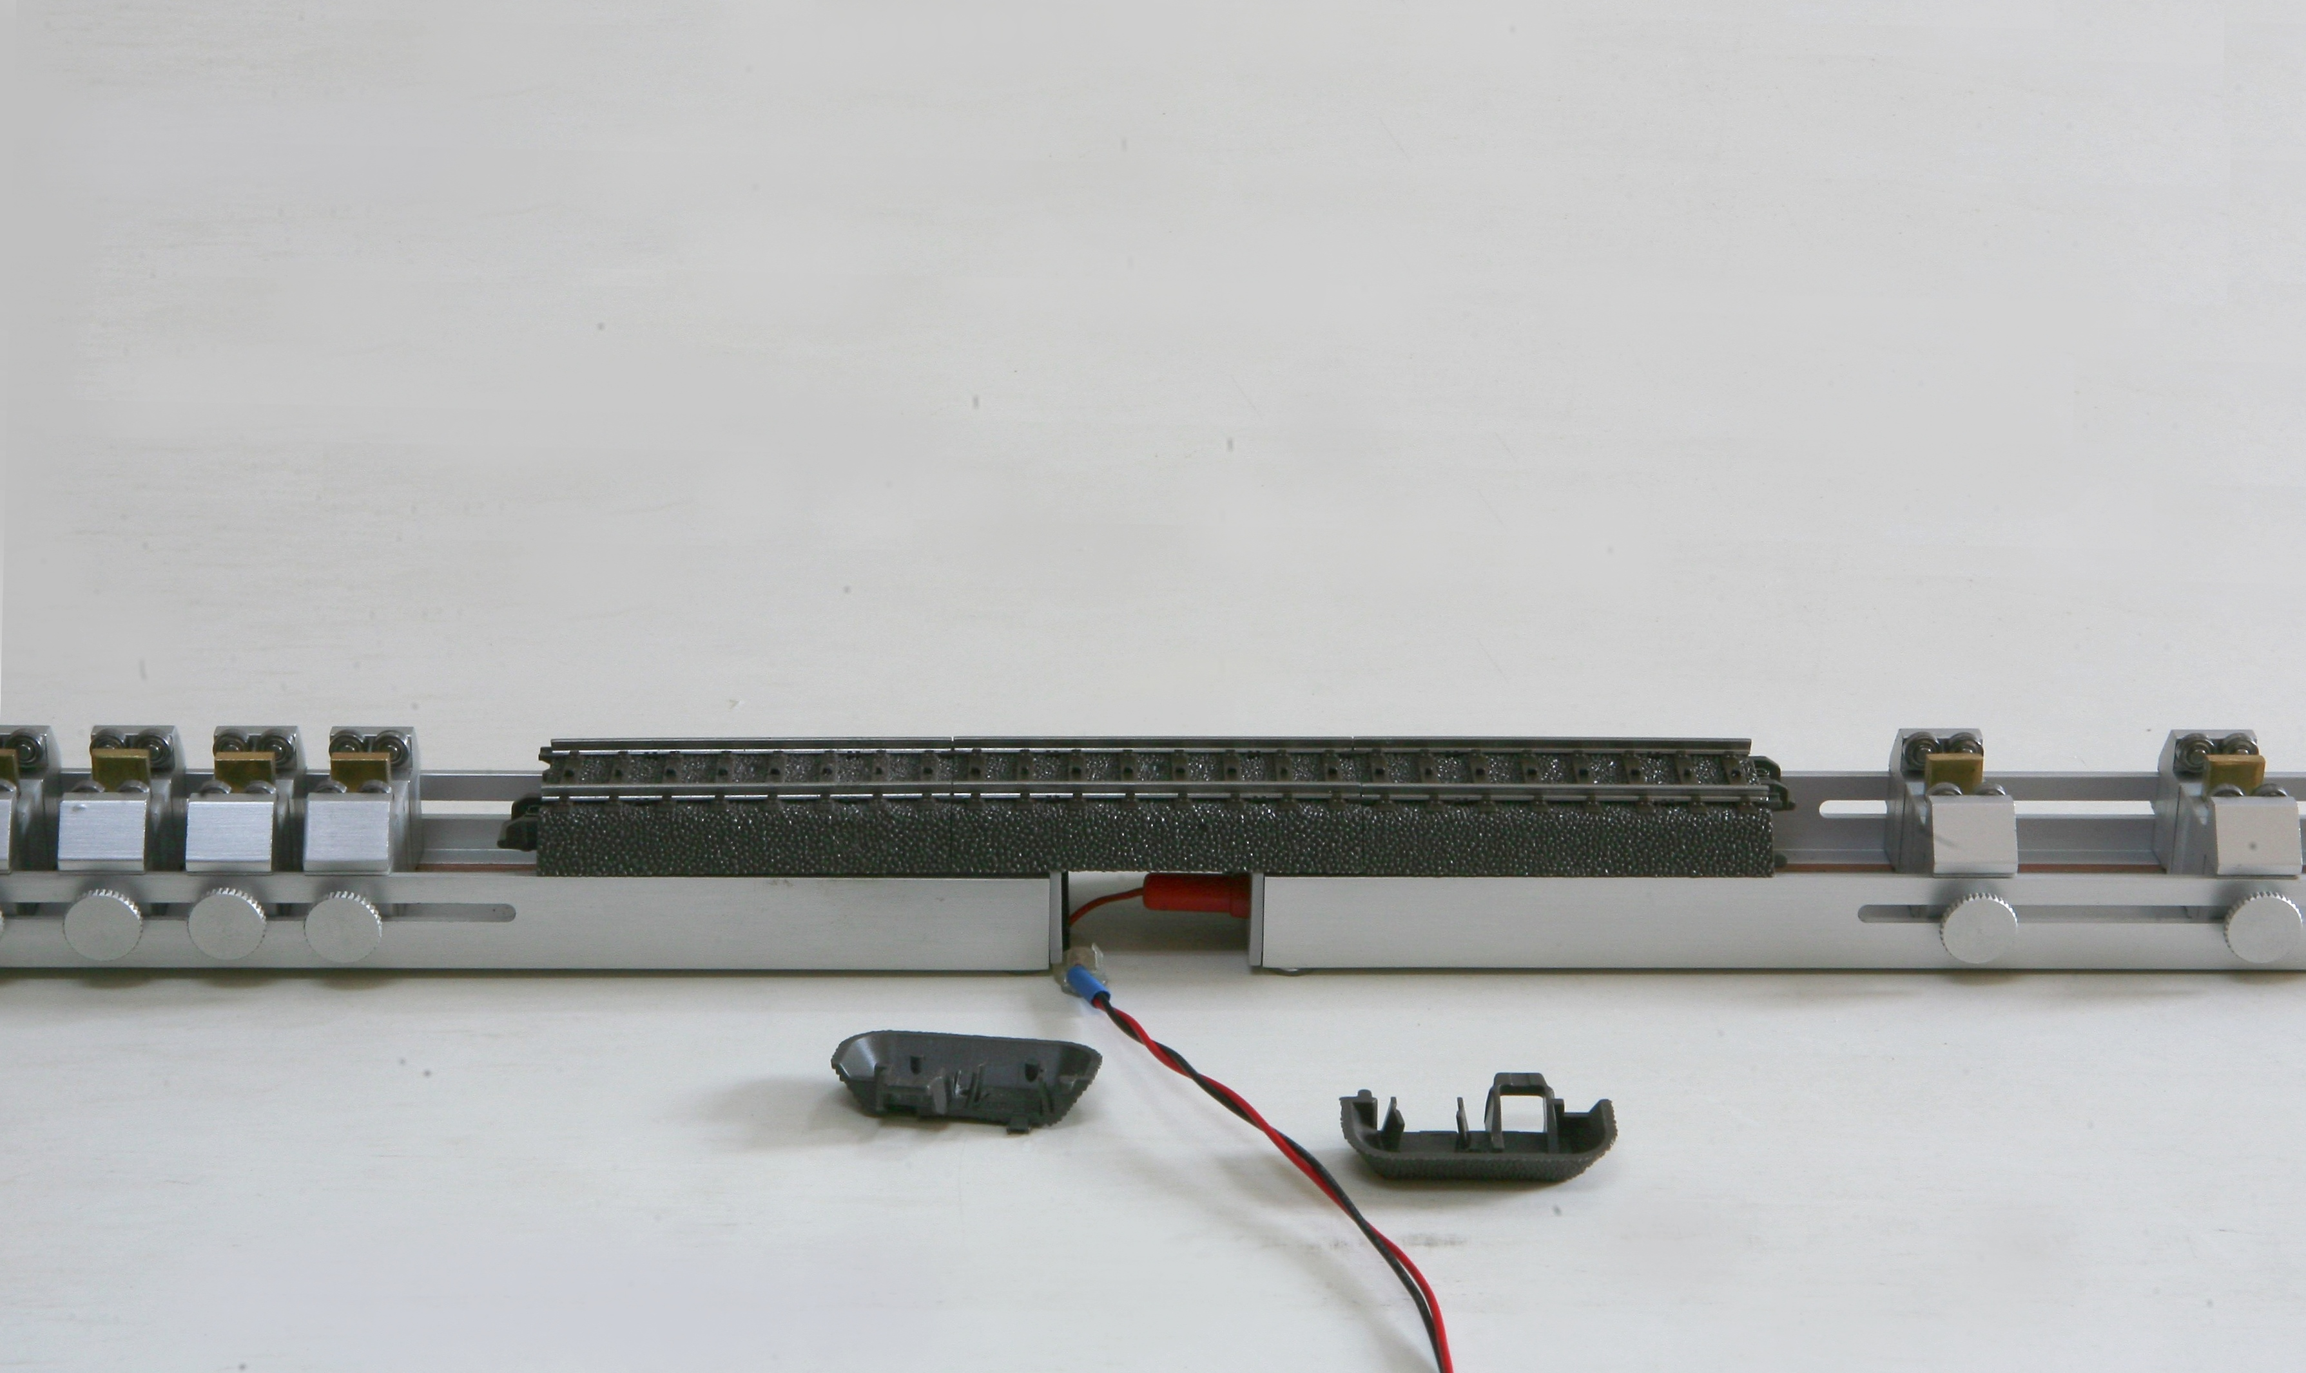

Notice: The connected AC track must be cut off from both right and left rails link. Please check the picture.
